16.42: a) In terms of the period of the source, Eq. (16.27) becomes

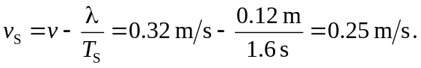

b) Using the result of part (a) in Eq. (16.18), or solving Eq. (16.27) for 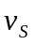 and substituting into Eq. (16.28) (making sure to distinguish the symbols for the different wavelengths) gives 